# Create Azure Virtual Network

Azure Resource Group: V2GTN

GTN Subnet Available: 10.10.4.0/24

GTN Prod VPN IP: 213.42.31.146

Our Old Static IP: 23.96.126.14 (GTNVPN-PublicIP)

New Public IP Address: 20.232.123.9 (V2GTN_VirtualNetworkGateway_PublicIP)

1. Create Azure Virtual Network

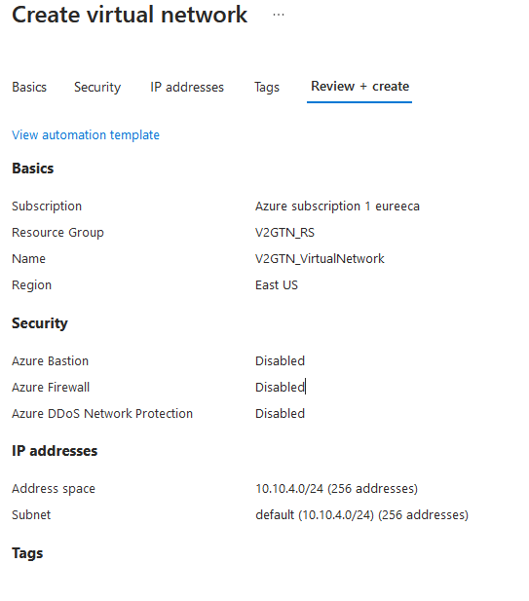

Go to the newly created Virtual Network and go to the Subnets Settings

Add a new Gateway Subnet

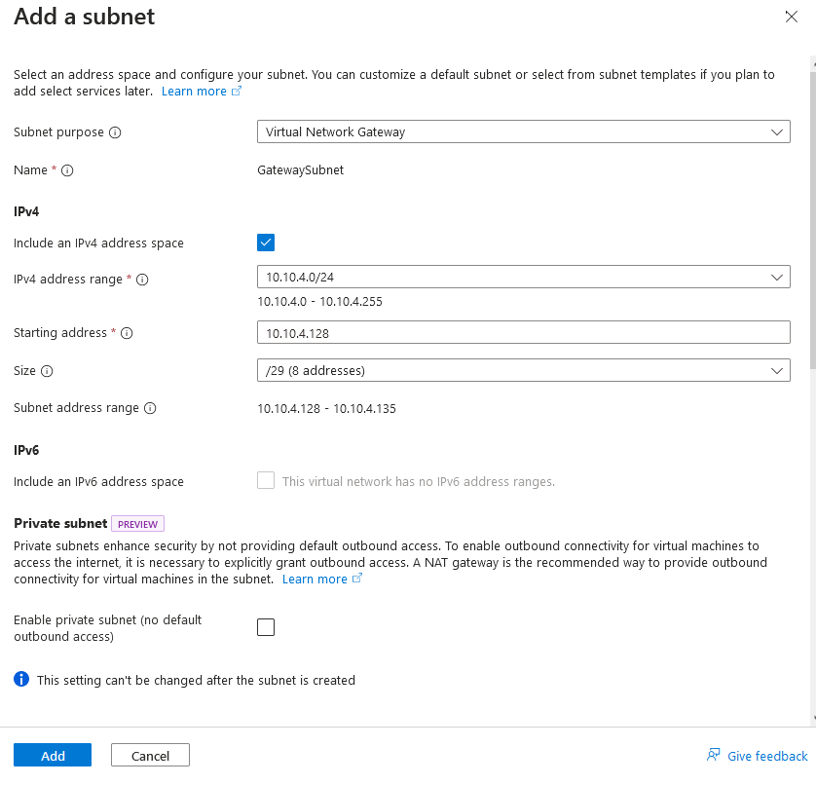

· Create Virtual Network Gateway

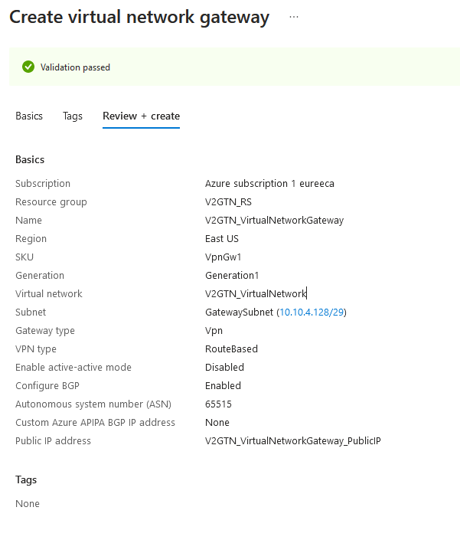

Create a Local Network Gateway.

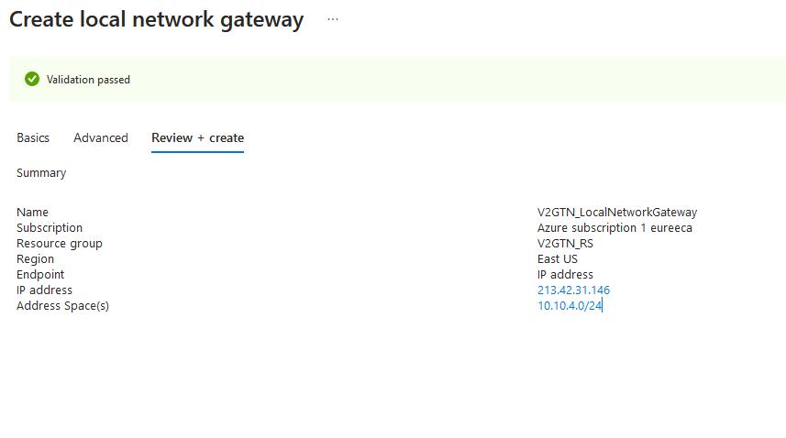

Create a new connection between the Virtual network gateway and the Local network gateway as

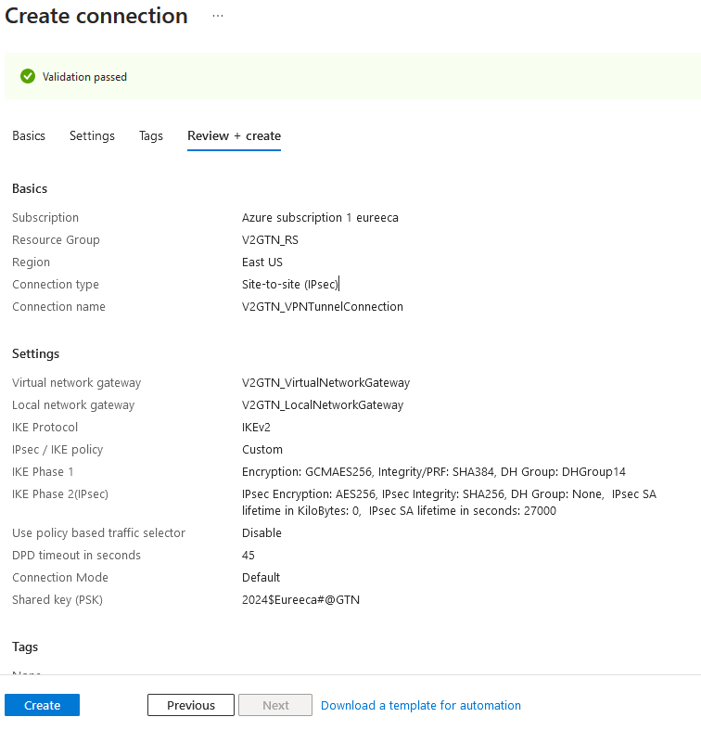

Replicate the VM from the Old Image, by creating the Disk Snapshot.

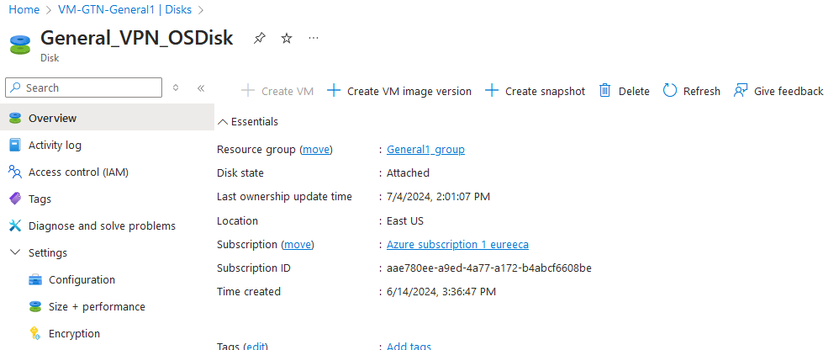

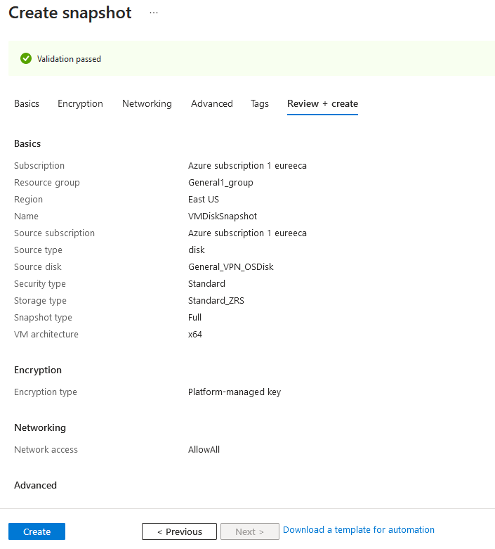

Based on the Snapshot, create a new Disk, which will be used to create the new VM

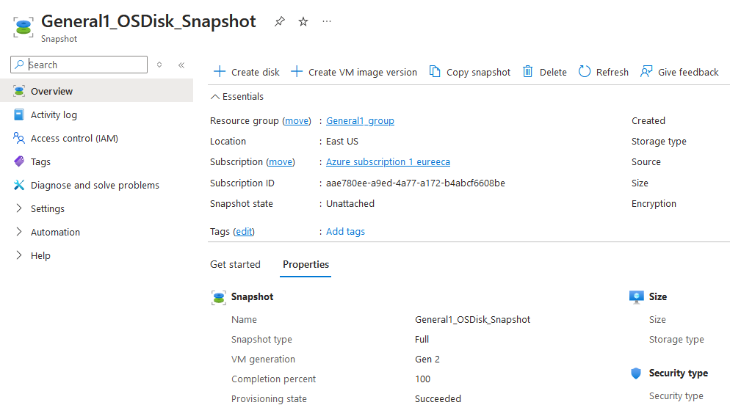

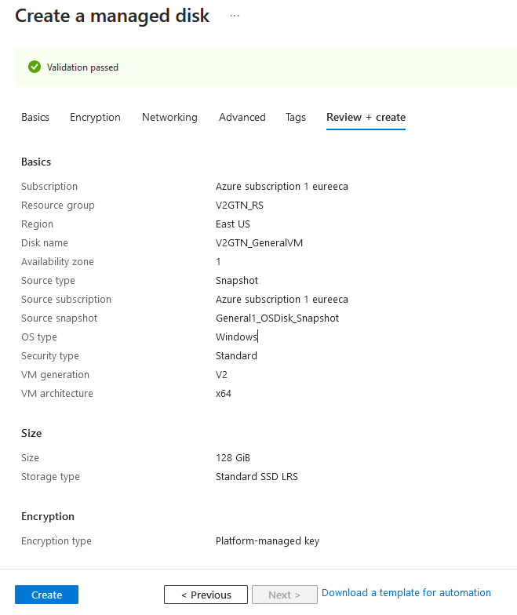

Now create a new VM baaed on the Disk we have just created.



